**Kaléko, Mascha (1907-1975)**

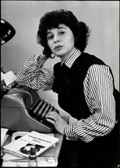Mascha Kaléko was a transnational Jewish German-language poet and one of the few female representatives of the New Objectivity (Neue Sachlichkeit). Her early works include *Das lyrische Stenogrammheft* (“The Lyrical Notebook in Shorthand. Poems of the Everyday”; 1933) and *Kleines Lesebuch für Große* (“Little Reading Book for Big People. Things That Rhyme and Those without Rhyme or Reason”; 1934), both of which were blacklisted by the Nazis in 1937. After fleeing with her family to New York in 1938, Kaléko continued to publish her poetry in German. Although she received the Fontane Prize in 1960, Kaléko refused to accept the award because it was to be handed over by a former Nazi official. Because of her early blacklisting and because her later work necessarily reached a more limited audience, Kaléko has largely been overlooked by the English-speaking world. Kaléko died from stomach cancer on January 21, 1975 while in Zurich.

© Rowohlt Archiv  
Mascha Kaléko.

url: http://archiv.lange-nacht-der-museen.de/31/programm/museum_156.html

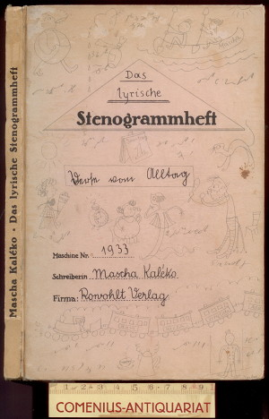Mascha Kaléko was born Golda Malka (Mascha) Aufen on June 7, 1907, in what is now Chrzanów, Poland. As the illegitimate daughter of a Russian merchant, Fischel Engel, and a Moravian-Austrian mother, Rozalia Chaja Reisel Aufen, Kaléko struggled with both her Jewish heritage and her identity as a national subject, an identity that was continually revised throughout her lifetime due to her move to Germany in 1914, subsequent exile, and her relocation to New York and later Jerusalem. Indeed, after Kaléko’s parents married in 1922 in order to legitimize both Mascha and her younger sister, the newly-christened Mascha Engel told a former classmate, Edith Lewin, “I have a new name. My name is no longer Aufen.” These themes of identity, isolation, exile, and homesickness are recurrent throughout Kaléko’s poetic oeuvre.

Semi-autobiographical in nature, Kaléko’s poetry can be roughly divided into four periods, each of which corresponds to a momentous shift in her life. The first of these periods spans from 1929 to 1932 and follows immediately upon her education in philosophy and psychology at several Berlin universities, including Humboldt-Universität, and her marriage to the linguist and scholar Saul Kaléko in 1928. 1929 witnessed the publication of Kaléko’s first poems in the magazine *Der Querschnitt*, which were soon followed by the regular publication of her poems in various other newspapers and magazines, including *Vossischen Zeitung* and *Welt am Montag*. Because of the simplicity of her language and her use of Berlin colloquialisms, Kaléko has been classified as one of the few female representatives of the New Objectivity. Perhaps uniquely among this group, Kaléko’s poems blend a deep melancholy with a subtle irony that lends a distinctively personal character to her poems. It was also during this time that Kaléko frequented the *Romanisches Café*, a gathering place for literary figures including Erich Kästner, Joseph Roth, Kurt Tucholsky, and Franz Werfel.

Cover of Kaléko’s first book of poetry

url: http://book.ac/116796.html

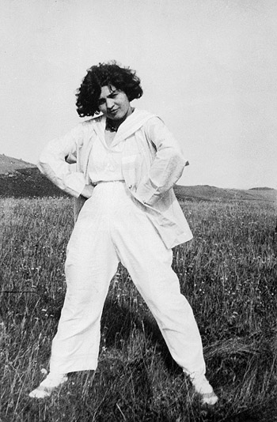

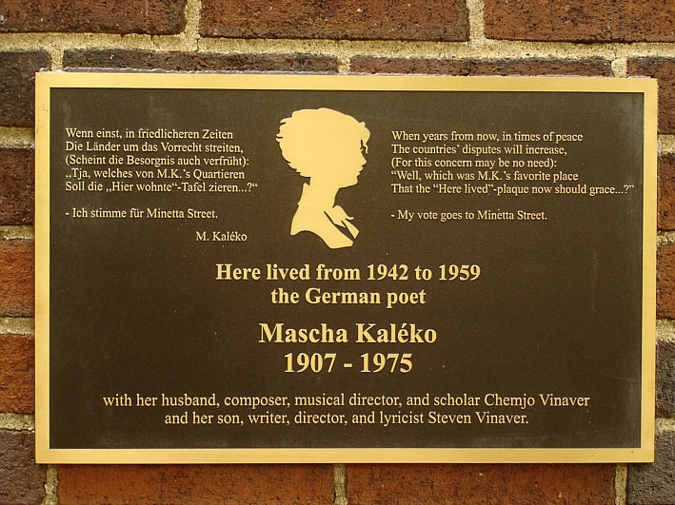The publication of Kaléko’s first volume of collected poems, *Das lyrische Stenogrammheft. Verse vom Alltag* appeared in January of 1933, coinciding with Hitler’s rise to power. Even as this marked the first major recognition of Kaléko on the literary stage, so was it the beginning of her “forced silence,” as Andreas Nolte has called this period. Kaléko was not recognized as a Jewish writer for several years, and her second volume of poetry, *Kleines Lesebuch für Große. Gereimtes und Ungereimtes* was published at the end of 1934, appearing in four editions through November 1936. Nonetheless, in August of 1935, Kaléko was barred from the State Literary Guild (“Reichschrifttumskammer”), and in January of 1937, both of her books of poetry were blacklisted. These events coincided with a personal crisis in Kaléko’s life: In 1936, Kaléko had the son of her lover, Chemjo Vinaver, who was a Jewish composer and scholar of music. Mascha divorced her husband Saul in January of 1938 and married Vinaver the following week. Later that same year, Mascha Kaléko (who retained her first husband’s last name), Vinaver, and their son Steven fled from Nazi Germany to New York City.

Mascha Kaléko, Hiddensee 1930

© DLA Marbach

url: http://www.literaturhaus-berlin.de/archiv-statisch/unten/prosa/kaleko.html

Kaléko and Vinaver lived in New York City from 1938 to 1959 (with a short stint in Hollywood, CA in 1940). Although she became an American citizen in 1940 and applied herself to writing scripts for advertisements, Kaléko refused to write poetry in English. As such, her poetry had a limited audience in the USA. While several of her exile poems found a home in the New York emigrant journal *Aufbau* (“Reconstruction”), the third volume of her poetry, *Verse für Zeitgenossen* (“Verses for Contemporaries”) was not published until Schoenhof Verlag, a publishing house in Cambridge, MA, picked it up in 1945. Unlike her earlier work, Kaléko’s poetry from this period began to address Judaism, albeit in a manner that Jutta Rosenkranz describes as affected and lacking her characteristic wit.

Plaque in Minetta St., New York City, commemorating Kaléko

© Nicole Dreyfus

url: http://www.kaleko.ch/index.php?option=com_content&task=blogsection&id=4&Itemid=46

Recordings of Kaléko reading seven of her poems, including “Interview mit mir Selbst” are available at: http://www.lyrikline.org/en/poems/interview-mit-mir-selbst-1586#.VVZnklVVikp

Kaléko and Vinaver again relocated – this time to Jerusalem – in 1959. Although this final period in her life was marked by greater poetic success, such success was marred by Kaléko’s overwhelming isolation after the death of her son in 1968 and that of her husband in 1973. Furthermore, while she was recognized as the recipient of the Fontane Prize for her poetic achievements in 1960, Kaléko refused the award as it was to be handed over by a former Nazi official. Her poetry of this period includes *Das himmelgraue Poesiealbum der Mascha Kaléko* (“The Sky-Gray Scrapbook of Mascha Kaléko”), published in 1968; and *In meinen Träumen läutet es Sturm* (“Bells Keep Ringing in My Dreams”), published posthumously in 1977. The poems in these collections are expressive of the deeply felt loneliness and melancholy that beset Kaléko during this period.

On January 21, 1975, Kaléko died from stomach cancer while in Zurich on her way back to Jerusalem from a visit to Berlin. She is buried at the Jewish Cemetery in Zurich.

**Selected List of Works**

**In German:**

*Das lyrische Stenogrammheft* (1933)

*Kleines Lesebuch für Große* (1934)

*Verse für Zeitgenossen* (1945)

*Der Papagei, die Mamagei und andere komische Tiere* (1961)

*Das himmelgraue Poesiealbum der Mascha Kaléko* (1968)

*Wie’s auf dem Mond zugeht* (1971)

*In meinen Träumen läutet es Sturm* (1977)

**In English:**

*“No matter where I travel, I come to Nowhereland”: The Poetry of Mascha Kaléko*, trans. Andreas Nolte (2010)

**References for Further Reading:**

Nolte, Andreas. *“Mir ist zuweilen so als ob das Herz in mir zerbrach”: Leben und Werk Mascha Kalékos im Spiegel ihrer sprichwörtlichen Dichtung*. Bern: Peter Lang Verlag, 2003.

Rosenkranz, Jutta. *Mascha Kaléko: Biografie*. Munich: Deutscher Taschenbuch Verlag, 2007.

Zoch-Westphal, Gisela. *Aus den sechs Leben der Mascha Kaléko*. Berlin: arani-Verlag, 1987.

-Christian Howard, University of Virginia